COVID-19 & PEOPLE WITH TYPE 1 DIABETES
March 2020
GOVERNMENT RECOMMENDATIONS ON SOCIAL DISTANCING FOR PEOPLE LIVING WITH DIABETES
We are keen to support you during the Covid-19 pandemic. Although people with diabetes are not more likely to catch Covid-19, the risks of becoming very unwell if you do get it are greater. As such, the government have recently recommended extreme social distancing measures for people living with diabetes. This is for a period of at least 12 weeks from the 16th of March on.
The full guidance can be found at: https://www.gov.uk/government/publications/covid-19-guidance-on-social-distancing-and-for-vulnerable-people/guidance-on-social-distancing-for-everyone-in-the-uk-and-protecting-older-people-and-vulnerable-adults
A summary of this guidance is below. People with diabetes fall into the ‘vulnerable group with an underlying health condition’ in the below table.
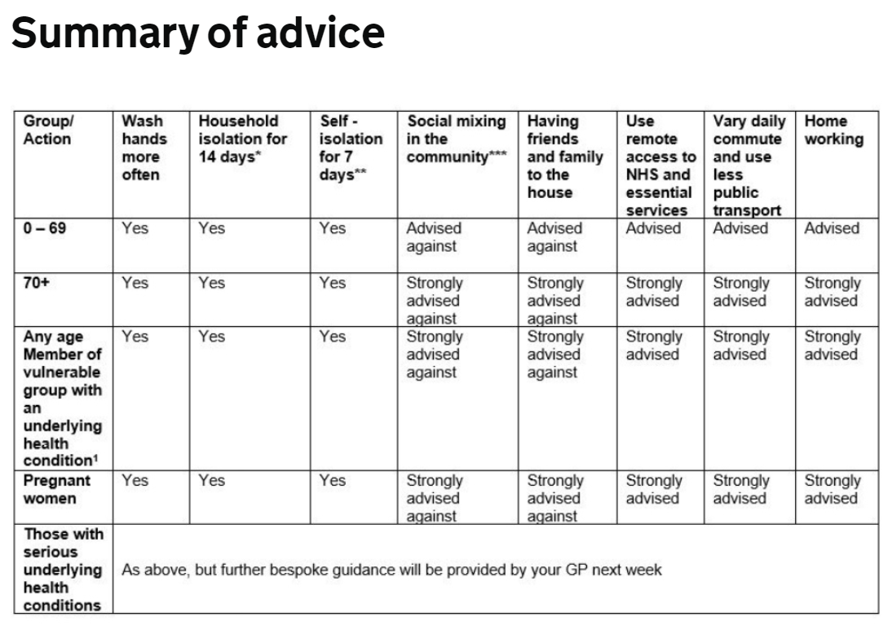
DIABETES UK INFORMATION
More information on diabetes and Covid-19 and diabetes can be found on the Diabetes UK website at: https://www.diabetes.org.uk/about_us/news/coronavirus
BE PREPARED
So that you have the equipment to cope during either self-isolation or illness please ensure you have adequate supplies of the following at home:
- Insulin
- Blood glucose monitoring and/or Libre
- Blood ketone sticks and a blood ketone monitor (we would also suggest requesting 50 urine ketones tests as back-up in case the blood ketones strips run low during a period of illness)
Due to pressure on services, we suggest you submit your repeat prescription request at least 1 week before the items will be needed. If you are on an insulin pump please ensure you have adequate consumables and a back-up supply of both long and short acting insulin and needles.
SICK DAY RULES
Sick day rules can be found at: http://trend-uk.org/wp-content/uploads/2018/03/A5_T1Illness_TREND_FINAL.pdf and the content has been pasted below so you have easy access.
CONTACTING THE NORTH DERBYSHIRE DIABETES TEAM
If you are unwell and need support with increased insulin requirements during illness or diabetes sick day rules, please call us:
- The contact number for urgent advice is 07880 147785 8am-5pm Monday to Friday. This is for use during the Covid 19 pandemic.
- Our Diabetes centre line is available Monday -Friday 8.30am-5pm for advice/routine queries on 01246 512113
- You can also contact the hospital switchboard on 01246 277271 and ask them to bleep the diabetes nurses on bleep 781 or 013 for urgent advice.

If you have a routine clinic appointment due soon this may be cancelled or you may be offered a telephone consultation instead. This is due to the current demands on the NHS. We will contact you regarding your appointment in due course. Please contact us if you need any support/guidance.

***copy of Trend sick day rules follow***

